

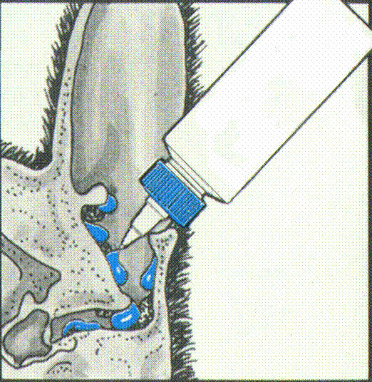

STEP 1: Aim the tip of the bottle into the ear canal and squeeze until full of cleaner.

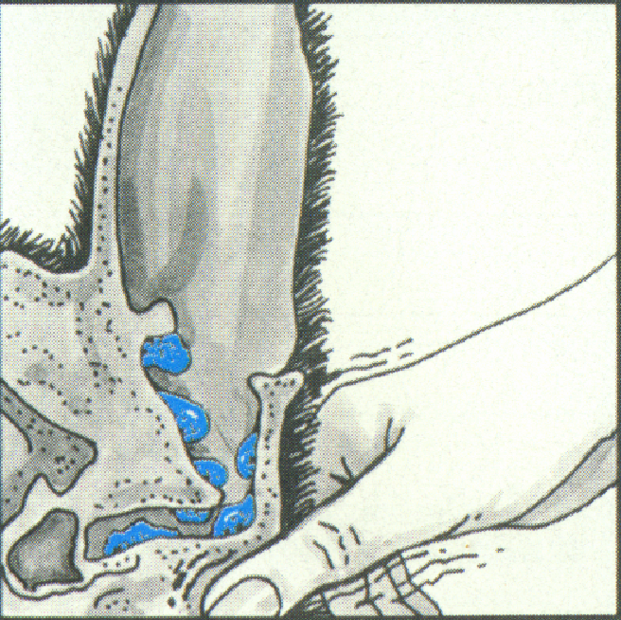

STEP 2: Gently massage the base of the ear for 60 seconds.

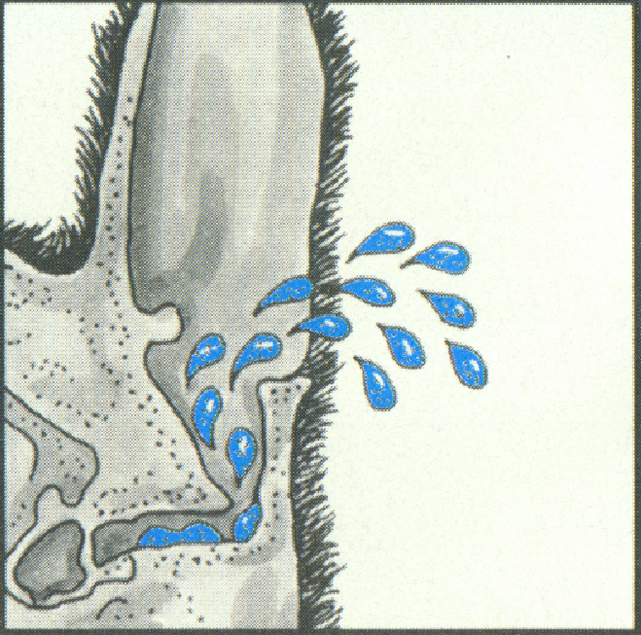
STEP 3: Allow pet to freely shake excess cleaner and debris from ear.



